Государственное бюджетное профессиональное образовательное учреждение

«Нижегородский радиотехнический колледж»

ОП.08 Основы проектирования баз данных

ОТЧЁТ

по лабораторной работе №6

## **Тема «Использование вложенных подзапросов в блоке FROM»**

**Цель работы:** изучение структуры запросов содержащих вложенный подзапрос в блоке FROM.

Выполнил: Проверил:

обучающийся группы 2ИСиП-19-1 Преподаватель

Мамонов Антон Гутянская Е.М.

Нижний Новгород

2021г.

26. Если будет несколько таких фамилий, то будет выведены данные об ещё лишних учениках.

select * from exam_marks where exam_marks.student_id in (select student_id from student where student.surname='Сергеев')

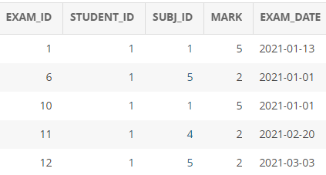

27. select concat(s.surname, ' ', s.name) as student

from student s, exam_marks em

where s.student_id=em.student_id

and em.subj_id=1

group by s.student_id

having avg(mark) > (select avg(mark)

from exam_marks)

28. select concat(s.surname, ' ', s.name) as student

from student s, exam_marks em

where s.student_id=em.student_id

and em.subj_id=7

group by s.student_id

having avg(mark) < (select avg(mark) from exam_marks)

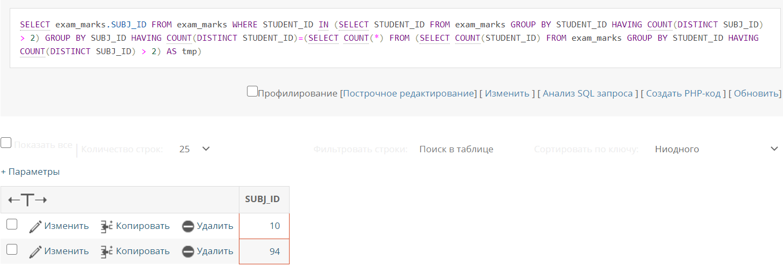29. select exam_marks.subj_id

from exam_marks

where student_id in (select student_id from exam_marks group by student_id having count(distinct subj_id) > 2)

group by subj_id

having count(distinct student_id)=(select count(*) from (select count(student_id) from exam_marks group by student_id having count(distinct subj_id) > 2) as tmp)

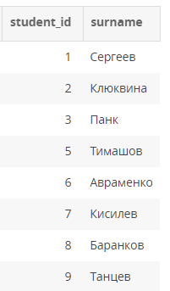

30. select s.student_id, s.surname

from student s

where s.stipend=(select max(stipend) from student where student.city=s.city)

31. select * from student

where not exists (select * from university where university.city=student.city)

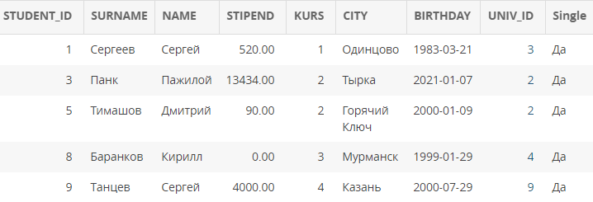

32. select * from student s

where s.student_id in (select s2.student_id from university u, student s2 where u.univ_id=s2.univ_id and s.city<>u.city)

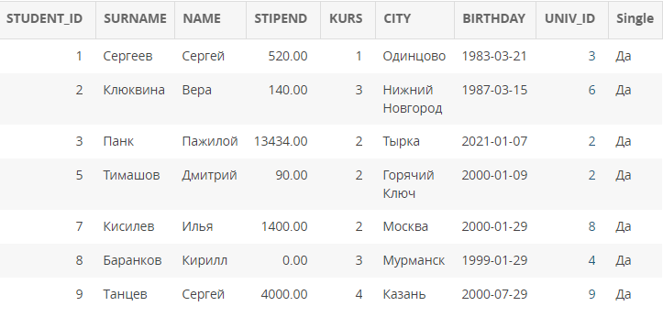

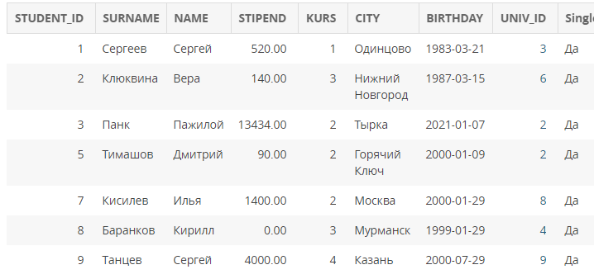select s.* from student s left join university u on u.univ_id=s.univ_id where u.city<>s.city

41. select 'высокий', univ_name, city, rating from university where rating >= 300

union

select 'низкий', univ_name, city, rating from university where rating < 300;

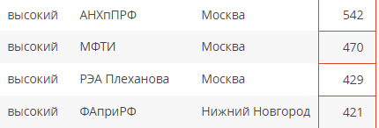

42. select 'успевает', surname, s.student_id

from student s where 2 < all(select e.mark from exam_marks e where s.student_id=e.student_id) and 1 > (select count(e.mark) from exam_marks e where mark is null and s.student_id=e.student_id) and 0 < (select count(e.mark) from exam_marks e where s.student_id=e.student_id)

union

select 'не успевает', surname, s.student_id

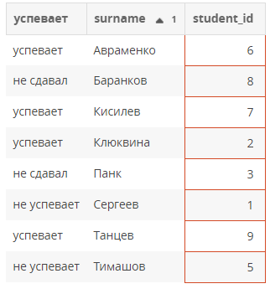from student s where 2 = any(select e.mark from exam_marks e where s.student_id=e.student_id) and 1 > (select count(e.mark) from exam_marks e where mark is null and s.student_id=e.student_id) and 0 < (select count(e.mark) from exam_marks e where s.student_id=e.student_id)

union

select 'не сдавал', surname, s.student_id

from student s where 1 <= (select count(*) from exam_marks e where mark is null and s.student_id=e.student_id) or 0 = (select count(e.mark) from exam_marks e where s.student_id=e.student_id) order by surname